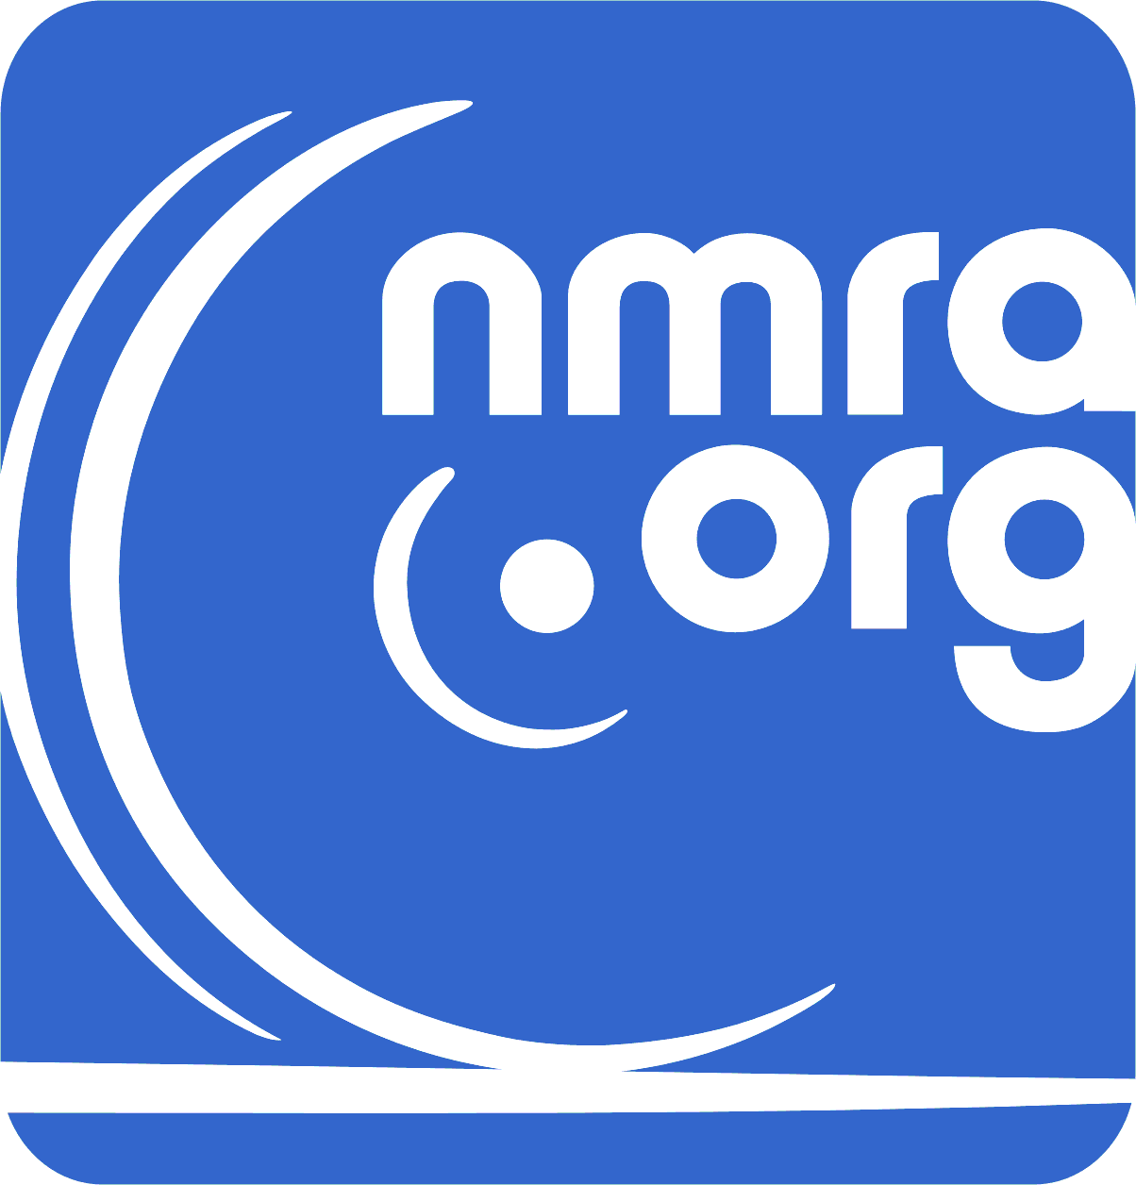 | 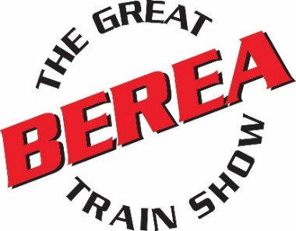 | 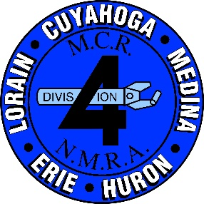

Greetings to our Not For Profit organizations,
It is time once again for show registration. Division 4 MCR-NMRA proudly announces our annual October model train show. The registration window has opened earlier than ever before .Fill out your reservation form and return at your earliest convenience. We look forward to your participation for this great event!

As before, the show will be at the Cuyahoga County Fairgrounds on Saturday and Sunday October 2 & 3, 2021. Show times will be 10:00 AM to 4:00 PM each day.

In the past we have not charged for the tables that you are displaying your information to the public. But the cost of those table keeps rising, so To help defray the cost of the tables, we will still give you 1 free table and charge $10 for each additional table.

- New Not for Profits need to get their name on our New Waiting List. This is done by returning the Not For Profit Reservation Contract with a check for $10.00(if you need a table). Your name is placed on the list by the post mark on your envelope.
- Organizations with trailers who will be checking in on Friday. I would like to get you checked in starting at 12 noon. If you can make it earlier contact me.
- There will be no one day displays! Any display leaving Saturday will not be invited back to future shows.
- Set up times: Friday 12:00 PM m—9:00 PM and Saturday 7 :00AM to 10:00 AM.
- There will be 24-hour security Friday evening through Sunday closing.
- Refund Policy: Any cancellations of dealer tables within the last thirty (30) days prior to the show will result in the dealer forfeiting their table money. Refunds will be considered and granted on a case by case basis. The decision is made by the Division 4 Board of Directors at the Director’s meeting held after the show.
Request for refunds must be made in writing and directed to the Board of Directors.
- We again will be issuing wrist bands for identification of our dealers. The food vendor will allow you to use the Dealer Only line at the food vendor wagons. The bands will also help us to keep patrons out of the buildings during the show hours of our Sunday Dealers Only “Walk, Talk and Swap” taking place prior to the opening of the show on Sunday.
- A comprehensive list of all vendors will be compiled for the Ohio Department of Taxation (Sales Tax). Please avoid problems and get your vendor’s license and be in compliance. Any questions can be answered by calling the Columbus Office of the Ohio Department of Taxation at 1-888-405-4089.

The Great Berea Train Show continues our tradition as the premier model railroad show in Northeast Ohio. Five modern made for commercial display buildings, wide family friendly aisles, space for you behind your tables and all in 70,000 square feet. These remain the trademarks of a Division 4 train show. I strongly encourage you to reserve your tables now to avoid being shut out! Come join us in October at the fairgrounds.

Best Regards, | Contact Info
David James / Show Manager | showmanager@thegreatbereatrainshow.org | 2650 Columbia Road
 | 440-785-9907 | Brecksville, OH 44141

Area Information
Hotels
Comfort Inn |  | Courtyard Days Inn |  | Hampton Inn & Suites
17550 Rosbough Dr. |  | 7345 Engle Rd 7233 Engle Rd |  | 7074 Engle Rd
520-448-3432 |  | 440-243-8785 440-207-9654 |  | 440-234-0206
Motel 6 |  | TownePlace Suites Crowne Plaza |  | Red Roof Inn
7219 Engle Rd |  | 7325 Engle Rd 7230 Engle Rd |  | 17555 Bagley Rd
440-234-0990 |  | 440-816-9300 440-243-4040 |  | 440-243-2441
Sonesta ES Suites |  | Extended Stay America
17525 Rosbough Dr. |  | 17552 Rosbough Dr.
440-234-6688 |  | 440-243-7024  Restaurants  Middleburgh Heights
Chipotle Olive Garden | Penn Station Subs Bob Evans Perkins |  |  | Max & Ermas | Taco Bell
Subway Arby’s | Pizza Hut McDonalds Burger King |  |  | Five Guys  Dunkin Donuts | Panera  Zoup
Wendy’s Wah Fu Chinese Brown Derby Brew Garden Jimmy John’s

Berea

Berea Depot Corner Stone Brewery Eastland Inn Tony K’s Zack’s Place Sweet Mango Thai

Olmsted Falls

Bistro Du Beaujolsis Falls Family Moosehead Hoof & Ladder

David James / Show Manager
2650 Columbia Road
Brecksville, OH 44141
440-785-9907
showmanager@thegreatbereatrainshow.cor

 | 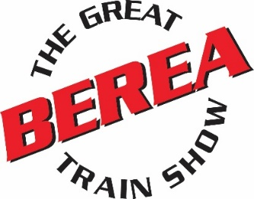 | 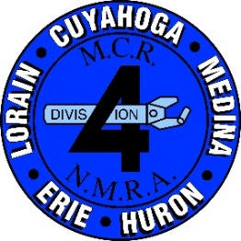

NOT FOR PROFIT TABLE RESERVATION FORM
SHOW DATES: OCTOBER 2-3, 2021
*** IMPORTANT ***
1. TGBTS correspondence will be done electronically. If you would like to opt out of this, please check the box in the registration form.
2. If you are new to our event, please check the box in the registration form.
3. Please check our website and dealer page for news and updates. www.thegreatbereatrainshow.org

NAME___________________________________________# TABLES _____X $10.00ea =_________
1 FREE TABLE
ADDRESS_________________________________________ AMOUNT ENCLOSED _______________

CITY/STATE/ZIP ____________________________________ Chairs needed ____ CK # _________

PHONE NUMBER _____________________________________ ELECTRIC _______ YES

EMAIL ________________________________________________________________

ORGANIZATION INFO # ________________________ NUMBER OF WRIST BANDS ____________
Please send us a list of names, we will then send the wristbands to the Group leader.

OPT OUT OF ELECTRONIC CORRESPONDEN CE ☐ ARE YOU NEW TO TGBTS? ☐

SPECIAL INSTRUCTIONS: ________________________________________________________________________
Please make your check payable to: Div. 4 MCR NMRA
Mail to: Dave James, 2650 Columbia Rd. Brecksville OH 44141
CONTRACT RULES
- Dealers/ Organizations bear sole responsibility for the collection and submission of State of Ohio sales tax and complying with all regulations thereof.
- Organizations agree to release Division Four Mid Central Region of the National Model Railroad Association from all liability for injury, loss or damage to themselves and their property.
- State fire regulations require that there be NO SMOKING in any Fairgrounds building.
- There will be NO ONE DAY DISPLAYS or SUB LEASING OF TABLE SPACE.

Dealer’s Signature ________________________________________ Date: ___________________

